Software Requirements Specification
For
DIPH
(Data-Informed Platform for Health)

Version: (2.0) Prepared By: - Tattva Foundation
Date: (06/10/2020)

Table of Contents
# | Topic | Page Number
1 | Introduction | 4
1.1 | Purpose | 5
1.2 | Scope | 5
1.3 | System Users | 5
1.4 | Overview | 5
2 | Proposed Solution | 6
2.1 | Key application modules of DIPH | 7
2.2 | Operating Environment | 7
2.3 | Design and Implementation Constraints | 7
2.4 | Assumptions and Dependencies | 7
2.5 | Design Considerations | 8
2.6 | Application Framework | 8
3 | DIPH Web Services API | 9
4 | External Interface Requirements | 10
4.1 | User Interface for DIPH Web Application | 10
4.2 | User Interface for DIPH Android Application | 10
4.3 | Server Requirement for DIPH | 10
5 | DIPH Class Diagram | 11
6 | DIPH Web Application Modules | 12
6.1 | Login | 12
6.2 | Forgot Password | 15
6.3 | User Dashboard | 15
6.4 | Primary Forms – Step 1A - Document and Database Checklist | 16
6.5 | Primary Forms – Step 1B - Health System Capacity Assessments | 17
6.6 | Primary Forms – Step 2 - ENGAGE | 18
6.7 | Primary Forms – Step 3 - DEFINE | 19
6.8 | Primary Forms – Step 4 - PLAN | 20
6.9 | Primary Forms – Step 5 – FOLLOW-UP | 21
6.10 | Supplementary Form - DATA EXTRACTION FROM STATE, REGIONAL AND DISTRICT/WOREDA LEVEL HEALTH DOCUMENTS | 23
6.11 | Indicator | 24
6.12 | Add Hierarchy | 24
6.13 | Lock/Unlock Current Cycle | 26
6.14 | General Guide | 26
7 | DIPH Android Application Modules | 27
7.1 | Login | 27
7.2 | Home | 29
7.3 | Side Panel | 30
7.4 | Primary Form - FORM - 1 PART A: (DOCUMENT AND DATABASE CHECKLIST) | 31
7.5 | Primary Form - FORM - 1 PART B: (HEALTH SYSTEM CAPACITY ASSESSMENTS) | 32
7.6 | Primary Form - STEP 2 - ENGAGE | 34
7.7 | Primary Form - STEP 3 - DEFINE | 35
7.8 | Primary Form - STEP 4 - PLAN | 37
7.9 | Primary Forms – Step 5 – FOLLOW-UP | 38
7.10 | Supplementary Form | 40
7.11 | Update local database | 41
7.12 | Sync to server | 41
8 | Data Dictionary | 41
9 | Other requirements and limitations | 55

Introduction
The Data Informed Platform for Health (DIPH) is a decision-making support system which facilitates review and use of data in local level decision-making in the health sector and is evidently an effective mechanism for multi-sectoral data sharing and data-based decision making using local program and service data at district level.

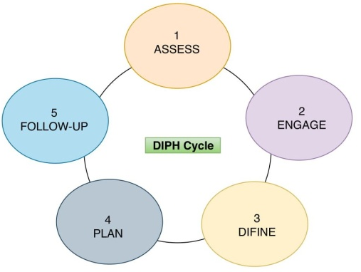
Districts are encouraged to select a theme or area of focus based on their local public health needs and based on the available data, local experiences, and health priorities and start a DIPH cycle, which ideally should last four to five months, allowing the districts to have at least 4 cycles in a year. Each DIPH cycle has a designated stakeholder as the theme leader, who is responsible for the overall execution of cycle specific DIPH steps. There can be different theme leaders for different cycles or the health district can designate one person as the theme leader for the entire duration (year) of the DIPH process. Each cycle consists of the districts collectively going through the following five steps (shown below), in doing so they use the DIPH web interface as a tool to gather, analyse, and monitor information and progress against set targets.
Each step has multiple forms attached to it, which are internally connected to share data across the platform. The forms can only be filled in an intuitive and logically sequentially manner.
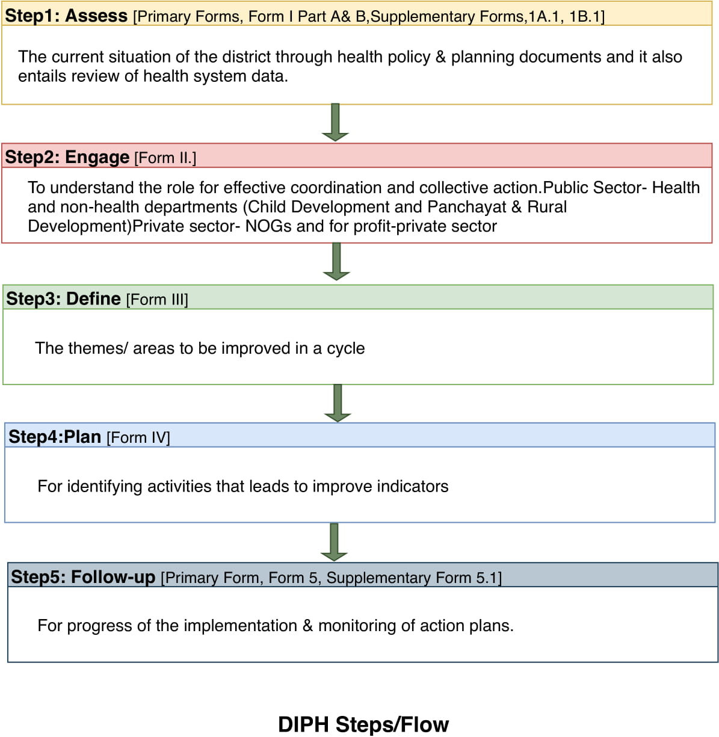

Purpose
The purpose of this document is to capture the software requirement details for DIPH which is designed for android tablets, android mobiles and desktops. This document will help in collecting and analyzing all the assorted ideas that have come up to define the system, its requirements with respect to its users. It also describes non-functional requirements, design constraints and other factors necessary to provide a complete and comprehensive description of the application's scope and requirements. Also, we should predict and sort out how we hope this product will be used in order to gain a better understanding of the System.
NOTE: This version of SRS is subject to changes depending on the feedback provided during the course of document evaluations by various stakeholders. A final SRS will be recorded once there is an official sign-off by the stakeholders on agreeing to freeze the requirements.

Scope
The Scope of this document is confined to capturing the requirements of the system and its interaction with other related applications.

System Users
Type | Action
Administrators | Will manage users, Districts and users data at different locations.
Data-entry users | Will collect the data from different sources and enter into system using web or android application.

Overview
DIPH is developed on latest cutting edge technologies and frameworks providing a decision-making support system which facilitates review and use of data in local level decision-making in the health sector. Two applications are made for using the DIPH platform, web application and android application. For online, DIPH web application is made and for areas where internet connectivity is low android version is used to collect data at different steps. Data collected in no or less internet network areas is later synced with central database using the sync functionality of android application. Data collected at different locations can be reviewed by the users who have admin rights.

Proposed Solution
DIPH will be used by different users to collect/manage/analyze data at different geographical locations. Its intuitively designed UI makes it easy to use at the point of care even with little to no training. DIPH can be used on variety of devices including android mobiles, android tables, desktops and laptops.
Following is the high-level system architecture of proposed solution for DIPH:-

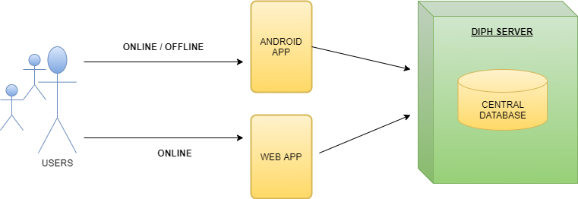

2.1 Key Application Modules of DIPH
S. No. | Head | Modules
1 | Administrator | Manage user module  Manage district module  Lock/unlock data at different geographical location module  Indicators management module  Users feedbacks and comments module
2 | Data-entry user | Data entry and data management at different geographical location module  Indicators management module
3 | Data Sync(Two-way) | Data syncing module(From android device to central DB)  Data update module(From central DB to android device)

2.2 Operating Environment
Operating environment for the DIPH system is as follows:
- Client/server architecture
- Operating system: Linux.
- Database: MySQL Database.
- Platform: Java
- Framework: Spring Boot and Hibernate.

2.3 Design and Implementation Constraints
DIPH system is developed using Java as core programming. Spring Boot and Hibernate frameworks are used. Front end is developed in Angular 8, Bootstrap, JQuery and HTML5.

2.4 Assumptions and Dependencies
- It is assumed that the department will provide their full support at all phases of software development life cycle.
- It is assumed that department will address all the administrative issues raised during development and will help resolve the same.
- Since the application will be hosted on a server (with database), accessing application will be heavily dependent on availability of the hosting server.

2.5 Design Considerations
Following are the design considerations for the” DIPH System”.

Architectural Goals
The overall architecture goals of the system are to provide a highly available and scalable websites for the users. The key Architectural goal is to leverage industry best practices for designing and developing a scalable, enterprise-wide application. To meet this goal, the design of the application will be based on MVC patterns as well as the industry standard development guidelines for building the application with content and user sharing.

Guiding Principles
Guiding principles provide a foundation which can be used to validate the design and ensure that it is aligned with application’s overall Architecture. Some of the guiding principles that are followed during the design and development are outlined below.

Scalable
Scalability is the ability of the platform to scale both up and down to support varying numbers of users or transaction volumes. The application should be able to scale horizontally (by adding more servers) or vertically (by increasing hardware capacity or software efficiency).

Flexible
Flexibility is the ability of the application to adapt and evolve to accommodate new requirements without affecting the existing operations. Flexibility is all dependent on the complexity of requirements.

Standards-Based
Portal services will comply with established industry standards. The standards-compliance will not only apply to application development but also to design, platform/infrastructure and other parts of the application. Examples of standards include HTML, MySQL and Java.

2.6 Application Framework
Spring is chosen as the application development framework for DIPH server side application development as it is the most efficient framework in terms of execution. For developing high performance web service APIs as well as web application.

DIPH Web Services API
This is the most important part of the DIPH system as it is the backbone of the whole system. This is the business layer to feed and supply data from and to the client devices. This is being built on the top of framework and following is the architecture of the same.
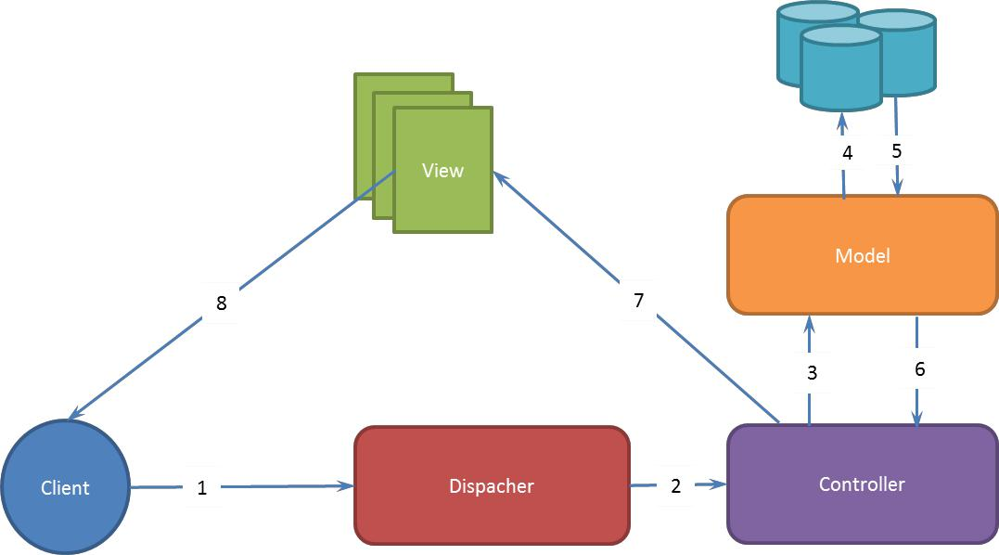

- Model: Model represents the application data communicating to database.
- View: View renders a presentation of model data. In our case, it will be in form of JSON for API request and HTML for dashboard requests.
- Controller: This is essential component of this design which handles requests and fulfill request made by the client.

- Dispatcher: Dispatcher receives the requests and sends to the appropriate controller.
- Policy Management: The policy management module is used to manage the policies.
- User Management: The user management module enables administrators to manage users.

External Interface Requirements

4.1 User Interfaces for DIPH Web Application

- Front-end: Angular 8, Bootstrap, JQuery and HTML5
- Back- end: Java.
- Frameworks: Spring Boot.
- Database: MySQL Database.

4.1 User Interfaces for DIPH Android Application

- Operating System: Android.
- Version: 5+.
- RAM: 4 GB or above.
- Language Used: Kotlin.
- Local Database: ormlite.
- Device to Sever Connection via: okhttp and retrofit.

4.3 Server Requirements for DIPH
- Operating System : Linux
- Central Processing unit : Quad Core
- RAM : 8 GB
- SSD : 500GB
- Display : Standard Output Display
- Bandwidth :100 Mbps dedicated
- Static IPV4 :1
- Communication Protocol : TCP/IP
- Devices : Chrome, Mozilla, IE and Safari (iOS)

5 DIPH Class Diagram

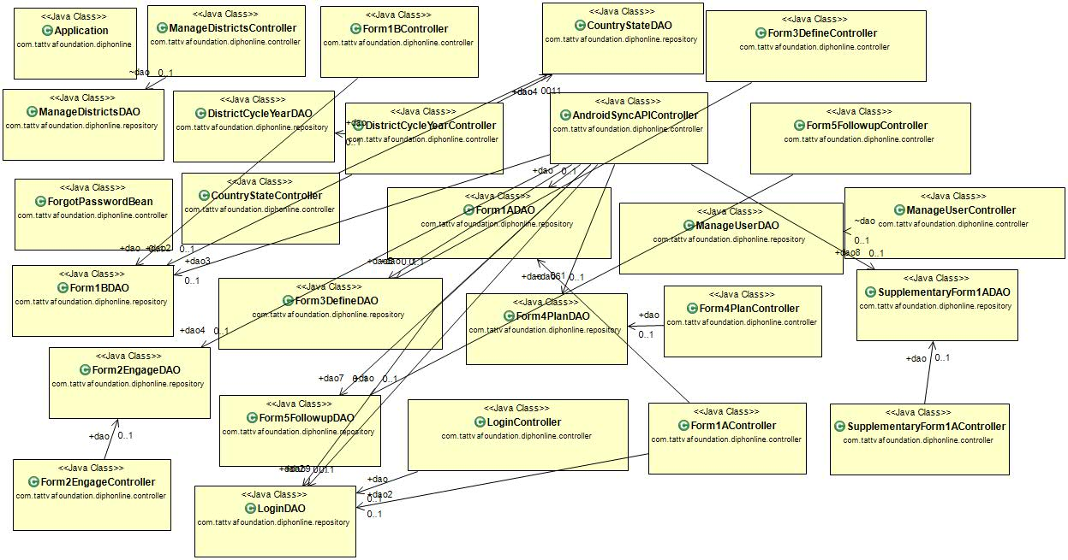

DIPH Web Application Modules

Login
Step 1 - User will access the application by entering URL http://diphonline.org:8080/diphonline.org/#/ in web browser. User will land on the web page shown below.
Step 2 - Using the dropdown options and select your 'Country' then click on the Submit button.
Step 3 - Using the dropdown options and select your 'Zone, District, Cycle and Year' then click the Submit button to go to next page and click the back button to go to previous page.

Step 4 - Enter the username and password then click the Login button for login and click the Back button to go to previous page.

Forgot Password
This feature will take username from the user and will send an email with password to the registered e-mail id. The e-mail id used will be the same as entered while registering a new user from user creation feature of DIPH.

User Dashboard
After the selection of respective District, Cycle and Year, the first page will be for ‘Primary forms’. In this interface, we are using four basic functionalities; i.e. NEW, VIEW, EDIT and Delete.
Primary forms: This page consists of Step 1A, Step1B, Step2, Step3, Step4 and Step 5.
Supplementary forms: This page consists of one supplementary form only.
Indicator list: Indicators are theme related coverage indicators captured by the national, regional, zone, or woreda level databases, which are commonly used at local level to track progress. There are three forms which are using these coverage indicators to track thematic work progress. The indicators are of three types, namely:
- Essential Indicators
- Optional Indicators
- Action Indicators

General Guide: A complete guide for all functionalities of DIPH.
Add Hierarchy: If user has admin rights this menu will be displayed.

Primary Forms – Step 1A - Document and Database Checklist
This form will help to identify the relevant documents and data forms required for situation assessment of a DIPH cycle, this needs to be filled in detail at the first DIPH cycle of any district. In the subsequent cycles, this checklist requires only updating based on the selected theme of the cycle.

Primary Forms – Step 1B - Health System Capacity Assessments
This form holds demographic characteristics, coverage indicators and assessment of health system capacity in terms of infrastructure, general resources (supplies, finance and technology) and human resources (skill level and availability of personnel).
Note-User will be able to fill the form 1 part B after filling form 1 part A, because both Form 1 Part A and B are interconnected.

Primary Forms – Step 2 - ENGAGE
‘Engage’ is the second step of the DIPH which is documented in form 2. The stakeholders on the identified theme (hereafter referred to as DIPH stakeholders group) are the decision makers for planning service provision.
In the first step of the form, the user will fill the primary and secondary Stakeholder name.

Primary Stakeholder: This refers to the main stakeholder department (health, non-health or private –for profit organizations &NGOs) who are responsible for providing direct services within the identified theme.

Secondary Stakeholder: This refers to the stakeholder department (health, non-health or private –for profit organizations & NGOs) who are responsible for providing supportive services within the identified theme.

Primary Forms – Step 3 - DEFINE
The form defines the areas to be improved on and details the possible solutions in terms of service delivery, workforce, supplies and technology, health information, finance and policy/ governance.

Primary Forms – Step 4 - PLAN
In this form, the theme-specific actions identified in Form 3 are further split into realistic action-points. The theme leader along with the stakeholders (department-wise) will discuss each action point and assign a person responsible for completion of each action point based on their work mandate in the district. To track the progress of the action points, measurable indicators will be coined for each action point.

Primary Forms – Step 5 – FOLLOW-UP
Follow-up is the last form in primary forms. Form is divided in two parts Part A and Part B ash shown below.
Part A form has 2 heads

- Major Stakeholders Involved in Each Meeting.
- Comparison of Key Coverage Indicator(s) in the DIPH Cycle: In this section user can set the time lines of the Indicator.

Part B, Action Points are mention below.

- Target (in Number): Target value auto fill from Plan Form.
- Progress of Indicators (in %): In this column user can fill the progress of the indicators in numbers.
- Person Responsible: Person responsible auto fill from Plan Form.
- Timeline: Timeline of action point is auto fill from Plan Form.
- Status of Action Points: In this column user can select the Status of Action Points Target of the theme.
- Revised Timeline: In this column user can set the new timeline of Action Points, if there is a change in timeline. User can also set the same date if there is no change in timeline.
- Change in Responsibility: In this column user can set the new responsible person for Action Points, if there is a change in person name. User can also set the same name if there is no change in person.

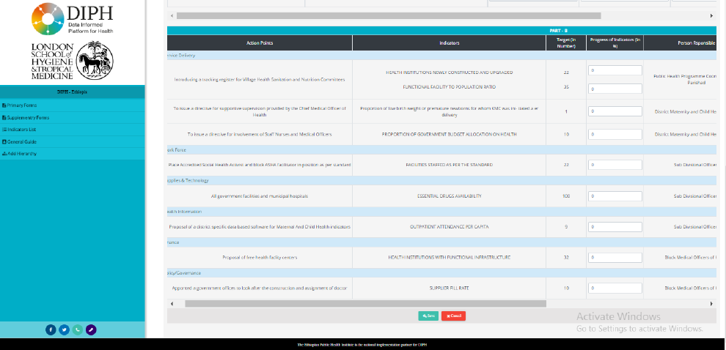

Supplementary Form - DATA EXTRACTION FROM STATE, REGIONAL AND DISTRICT/WOREDA LEVEL HEALTH DOCUMENTS
Supplementary form is also divided into two parts Part A and Part B but this form is not linked with any previous forms.
Part A
Part B

  - Indicator
Indicators are theme related coverage indicators used at local level to track progress. There are three forms, which are using these coverage indicators to track thematic work progress.
The indicators are of three types

1- Essential Indicators
2- Optional Indicators
3- Action Indicators

Add Hierarchy
It can only be used by administrator.

- Manage User: This section is only available to admin users, and using this admin can create login credentials for new users of the system or modify credentials of the existing users. Once admin has logged in, they can see the ‘Manage User’ option in side-menu. This option will not be visible for other users.
In manage-user section, the page consists of two features, namely:
- Create new users functionality, and
- A list of existing users.

- Manage District: It used to create new district for the current region in which administrator has logged in. if the district already exist then alert will be displayed. We can also delete already existing district for current logged in region.

Lock/Unlock Current Cycle
This option is displayed once we have click on the settings menu icon (displayed on the upper right corner home page, after user has logged in). This option will be disabled by default. And it will be activated after all the primary and secondary forms are filled. Clicking on this option/sub menu will lock all the form for the current cycle that is edit and delete link for all the form will be hidden and only view link be enable by default. The lock can be only unlocked/ removed by administrator for current cycle.

General Guide
It contains all the information for the individual modules of the website including primary forms, secondary form, and indicator, manage users, and forget password and deleting a form.
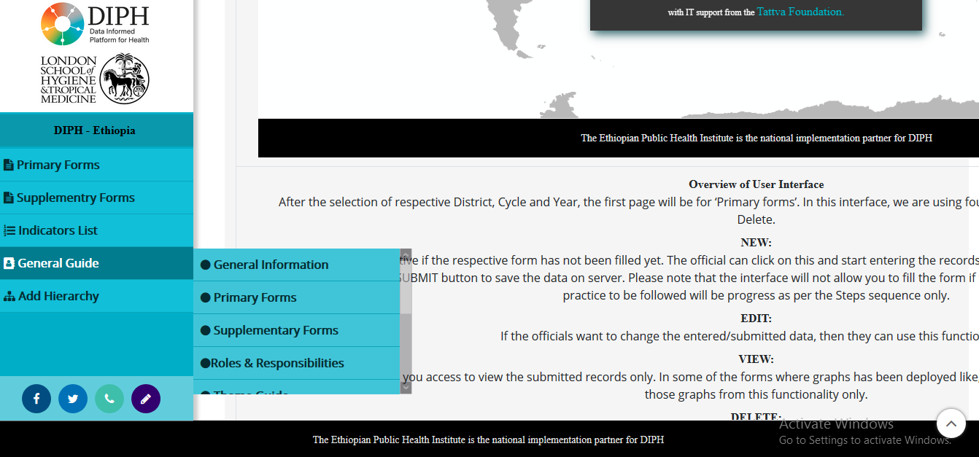

DIPH Android Application Modules

Login
Use the dropdown options and to select your 'Country' and 'Province', then click on the ‘Submit’ button.
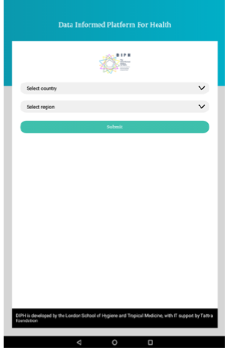
Use the dropdown options to select your 'Zone’, ‘District’, ‘Cycle’ and ‘Year' then the ‘Submit’ button to go to the next page.
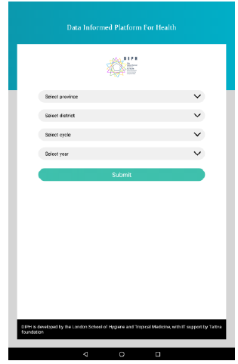
Enter the ‘Username’ and ‘Password’ then click the ‘Login' button for login.
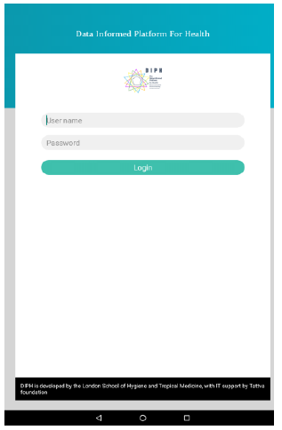

Home
After the selection of respective ‘District’, ‘Cycle’ and ‘Year’, the first page will be for Primary Forms. In this interface, we are using four basic functionalities: NEW, VIEW, EDIT and Delete.

NEW: This button will be active if the respective form has not been filled yet. The user can click on this and start entering the records as desired, but after completing the form it is important to click on the ‘SUBMIT’ button to save the data on the server. After filling the form you can see the next three functionalities VIEW, EDIT and DELETE.

EDIT: If the user wants to change the entered/submitted data for a particular form, then they can use this functionality to alter the submitted data and re-submit again.

VIEW: This functionality will give you access to view the submitted records only.

DELETE: ‘Delete’ button will be activated once the current form is filled. If the user fills the immediate next form, the delete button of the previous one will be hidden. Same process goes on until the last form is filled. Now, users cannot delete the previous form, so users have to delete from the last form first and then the previous dependent forms.

Side Panel
The side panel will help you to navigate between ‘Primary Forms’, ‘Supplementary Forms’, ‘Update local database’, and sync to server.
● Primary forms: This page consists of Step 1A, Step 1B, Step2, Step3, Step 4 and Step 5.
● Supplementary forms: This will give you access to only Step 1.
● Update local database: This option will fetch all the filled primary and secondary forms from the web to android app for the current cycle.
● Sync to server: This option will send all the filled/updated forms from the android app to the website.

Primary Form - FORM - 1 PART A: (DOCUMENT AND DATABASE CHECKLIST)
This checklist will help to identify the relevant documents and data forms required for situation assessment of a DIPH cycle, this needs to be filled in detail at the first DIPH cycle of any district. In the subsequent cycles, this checklist requires only updating based on the selected theme of the cycle.

Form Header: User should first fill & select the Date of the meeting, Venue of the meeting and Chairperson of the meeting in the form header part.

This form has 3 heads
- Policy and Planning documents
- Management and Services Provision
- Large Scale District Level Surveys

Primary Form - FORM - 1 PART B: (HEALTH SYSTEM CAPACITY ASSESSMENTS)
Users will be able to fill the Form 1 part B after filling Form 1 part A, because both Form 1 Part A and B are interconnected.

This form holds demographic characteristics, coverage indicators and assessment of health system capacity in terms of infrastructure, general resources (supplies, finance, and technology) and human resources (skill level and availability of personnel)

Primary Form - STEP 2 - ENGAGE
‘Engage’ is the second step of the DIPH, which is documented in form 2. The stakeholders on the identified theme (hereafter referred to as DIPH stakeholder group) are the decision makers for planning service provision.

Primary Form - STEP 3 - DEFINE
The form defines the areas to be improved on and details the possible solutions in terms of service delivery, workforce, supplies and technology, health information, finance and policy/ governance.
This form has 6 heads

1. Service Delivery:

Description of Problem from Health System Perspective: In this column users will explain the problem related to the Health System (Service Delivery).
Possible Solution to Improve: In this column, users will explain possible solutions to improve the health system.
Action required (write in priority order): In this column, users will explain required actions necessary step by step to be taken to improve the health system.
2. Workforce:

Description of Problem from Health System Perspective: In this column, users will explain the problem related to the Health System (Workforce).
Possible Solution to Improve: In this column, users will explain possible solutions to improve the health system.
Action required (write in priority order): In this column, users will explain required actions necessary step by step to be taken to improve the health system.
3. Supplies & Technology:

Description of Problem from Health System Perspective: In this column, users will explain the problem related to the Health System (Supplies & Technology).
Possible Solution to Improve: In this column, users will explain possible solutions to improve the health system.
Action required (write in priority order): In this column, users will explain required actions necessary step by step to be taken to improve the health system.
4. Health Information:
Description of Problem from Health System Perspective: In this column, users will explain the problem related to the Health System (Health Information).
Possible Solution to Improve: In this column, users will explain possible solutions to improve the health system.
Action required (write in priority order): In this column, users will explain required actions necessary step by step to be taken to improve the health system.

5. Finance:
Description of Problem from Health System Perspective: In this column, users will explain the problem related to the Health System (Finance).
Possible Solution to Improve: In this column, users will explain possible solutions to improve the health system.
Action required (write in priority order): In this column, users will explain required actions necessary step by step to be taken to improve the health system.
6. Policy/Governance:

Description of Problem from Health System Perspective: In this column, users will explain the problem related to the Health System (Policy/Governance).

Primary Form - STEP 4 - PLAN
In this form, the theme-specific actions identified in Form 3 are further split into realistic action-points. The theme leader along with the stakeholders (department-wise) will discuss each action point and assign a person responsible for completion of each action point based on their work mandate in the district. To track the progress of the action points, measurable indicators will be coined for each action point.

Primary Form - STEP 5 - FOLLOW-UP
Follow-up is the last form in primary forms. Form is divided in two parts Part A and Part B ash shown below.
Part A form has 2 heads

- Major Stakeholders Involved in Each Meeting.
- Comparison of Key Coverage Indicator(s) in the DIPH Cycle: In this section user can set the time lines of the Indicator.

Part B, Action Points are mention below.

- Target (in Number): Target value auto fill from Plan Form.
- Progress of Indicators (in %): In this column user can fill the progress of the indicators in numbers.
- Person Responsible: Person responsible auto fill from Plan Form.

Supplementary Form
Supplementary form is also divided into two parts Part A and Part B but this form is not linked with any previous forms.

  - Update local database
This option will fetch all the filled primary and secondary forms from the web to android app for the current cycle, district and year combination.

  - Sync to server

This option will send all the filled/updated forms from the android app to the website for the current cycle, district and year combination. And will show the data returned from the website server to the app.
- Data Dictionary

Below are the details of important and most commonly used tables in DIPH:-

- countries

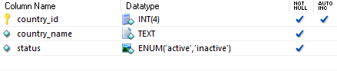
- region

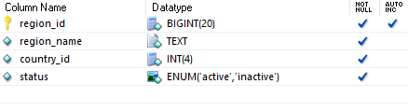
- country_states

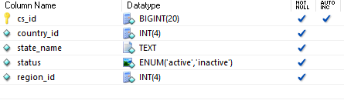

- district

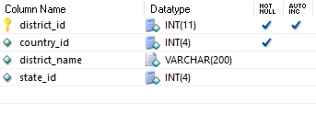
- cycle

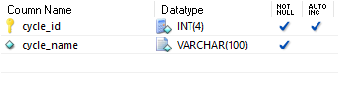
- data_extraction

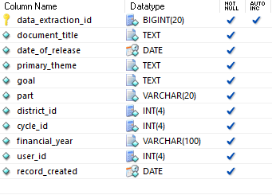

- dev_action_plan_action_points

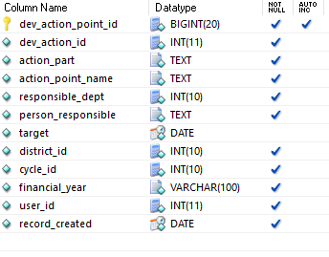
- dev_action_plan_details

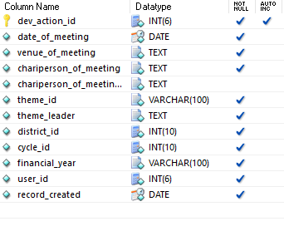

- dev_action_plan_indicators

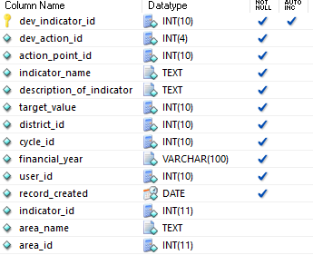

- doc_db_chklist

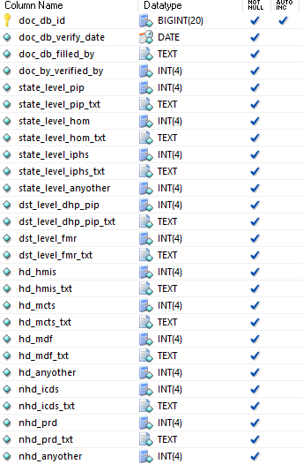
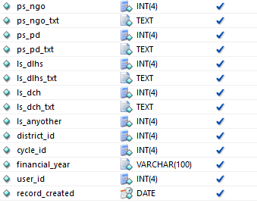

- doc_db_documents

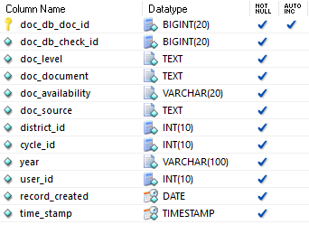

- followup_action_plan_tbl

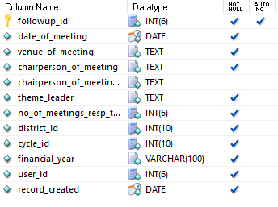
- followup_indicator_progress

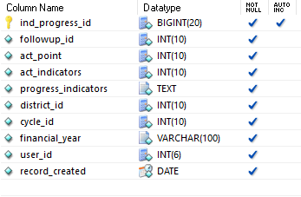

- form1b_selected_indicators

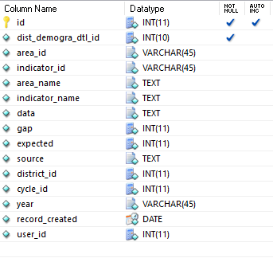
- form_1_2_data_extraction

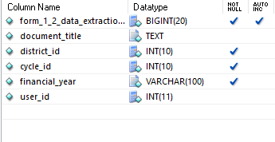

- form_1_2_data_extraction_actions

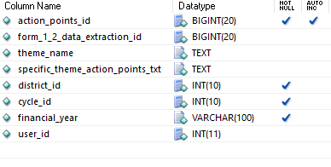
- form_1_2_data_themes

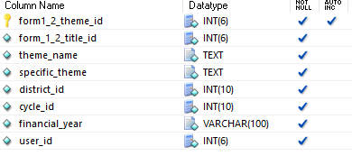
- form_1_3_1_analysis

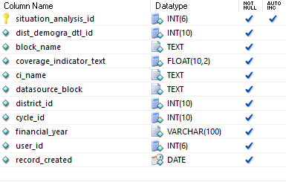

- form_1_4_dep_primary_resp

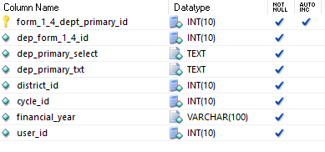
- form_1_4_dep_pvtsector_resp

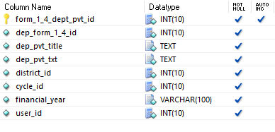
- form_1_4_dep_secondary_resp

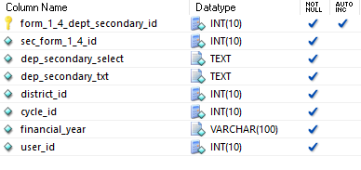

- form_1_4_issue_primary

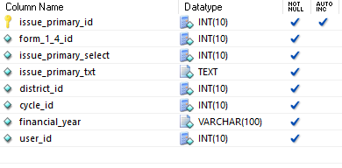
- form_1_4_issue_secondary

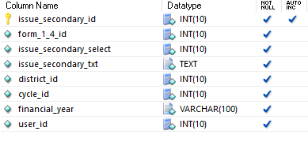
- form_2_filled_by

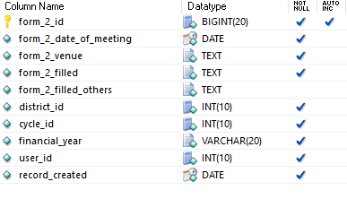

- form_2_section_details

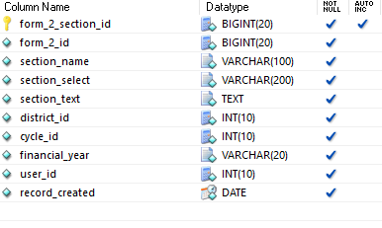
- form_2_stakeholders

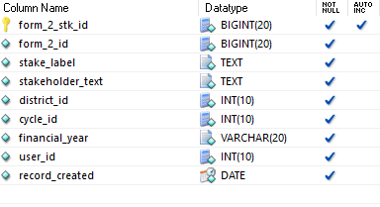

- form_3_1_action_part_engagement_action_req

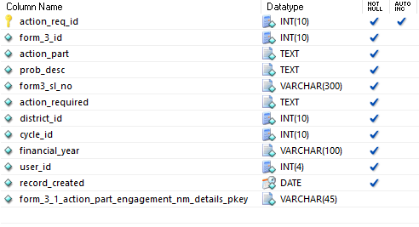
- form_3_1_action_part_engagement_nm

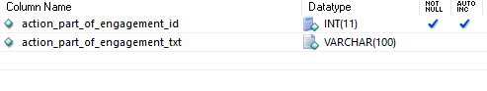
- form_3_1_action_part_engagement_nm_details

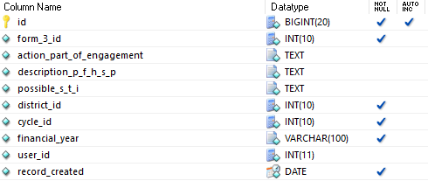

- geographical_combination

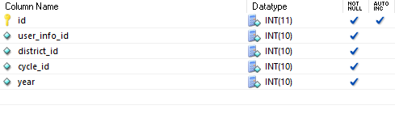
- indicators

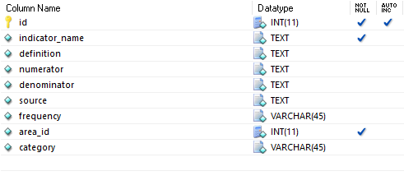
- allforms_cycle_lock_status

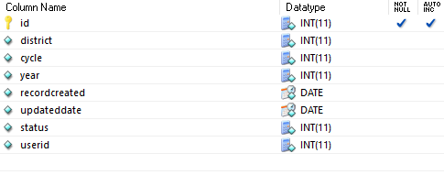

- Other requirements and limitations

Web application needs good internet connection for smooth working while android application needs no internet connection during data entry but for syncing data into the central database and updating the android device with latest data from central database good internet network is required.

